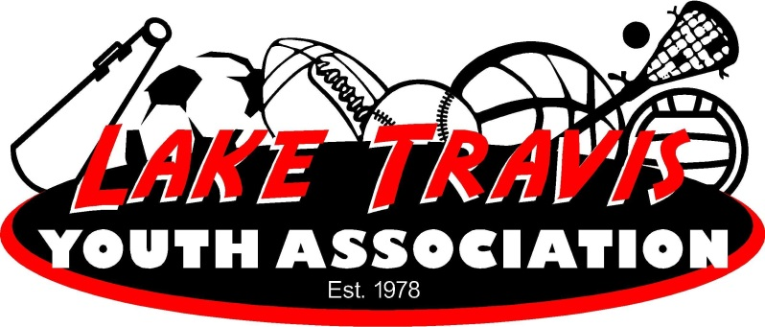

LTYA Golf is offered through the Hills Country Club.

What You'll Need: A set of golf clubs (clubs can be rented for the program). Golfers must wear a collared shirt, golf/tennis shoes and no denim

